**LUB KOOS HAUM DOLORES HUERTA CAMP LYFE**

**2023**

**MUAJ TSHWM SIM RAU**

**LUB XYA HLI HNUB TIM 23 – LUB YIM HLI HNUB TIM 52023**

Sau npe thiab tuaj koom nrog peb ntawm Camp LYFE, muaj pub dawb, ib hmos, yog ob-lub lim tiam rau ntawm kev ncaj ncees thiab kev ua yeeb yam rau cov hluas hnub nyoog 13-18 (uas tseem nyob hauv tsev kawm theem siab). Peb cov neeg txawj ntse thiab paub txog tus kws kos duab yuav muab kev cob qhia hauv tsib yam txuj ci uas tseem ceeb.

Yuav tsum nyob hauv xeev California, qhov kev nyiam yuav muaj kev cob qhia rau cov neeg nyob hauv Central Valley

**Kev ua las voos**

**Kev ua yeeb yam**

**Kev hais lus**

**Kev hus nkauj**

**Kev kos duab thiab ke sib tham**

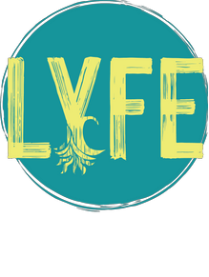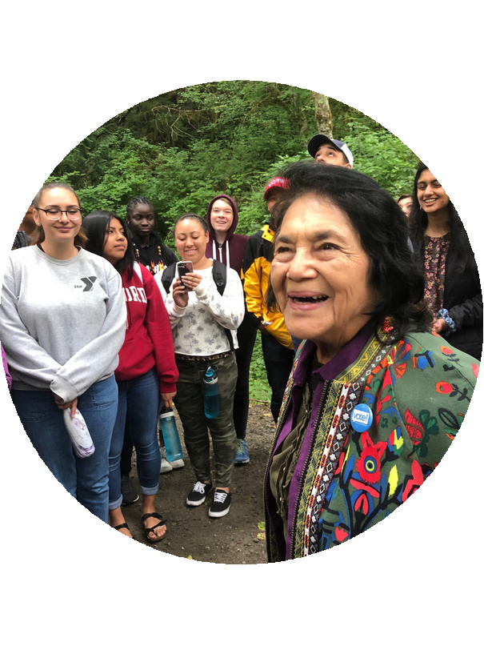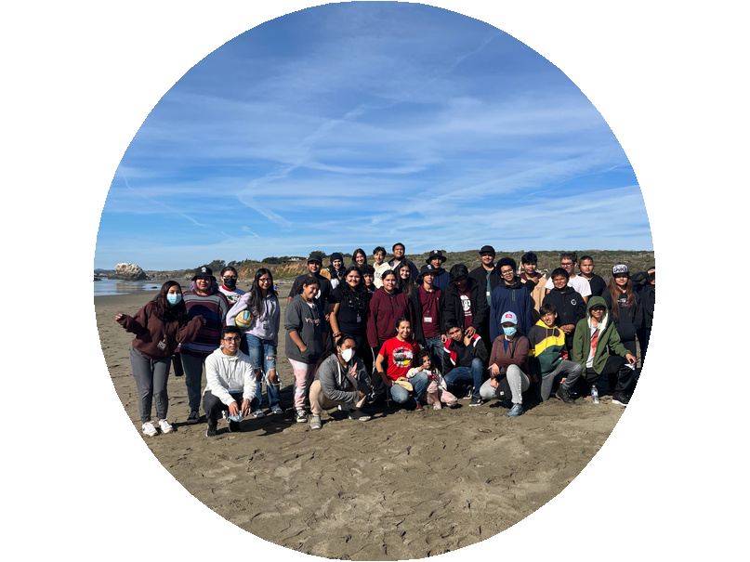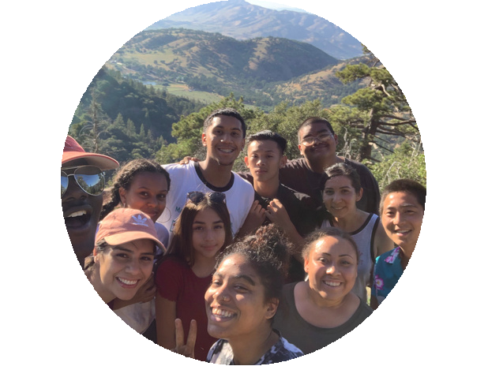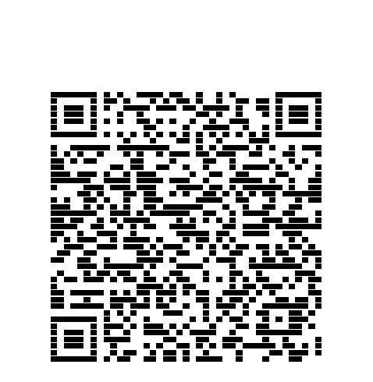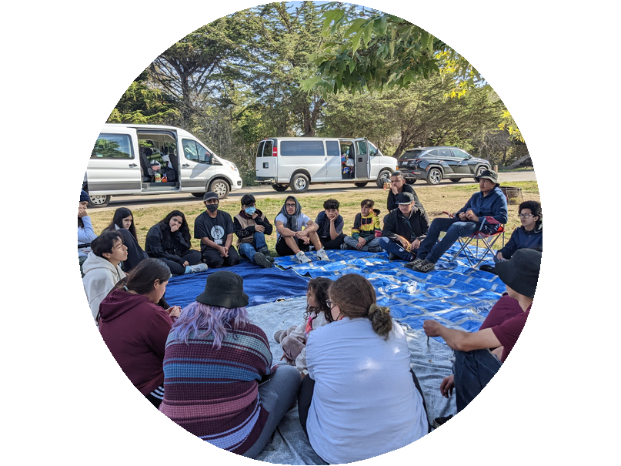

nDATion

Apply Today

**DAIM NTAWV SAU NPE YUAV TSUM XAS RAU LUB TSIB HLI HNUB TIM 15, 2023 THAUM 5:00PM.**

**Yog xav paub ntau ntxiv, mus saib peb tus vevxaib ntawm wwwdoloreshuerta.org los sis tiv toj peb ntawm camplyfe@doloreshuerta.org**